Introduction to JQuery

1. **Console "Hello Word" in document.ready function**

**index.html**

<!DOCTYPE html>

<html>

<head>

<title>Learn Jquery</title>

<script src="../jquery-3.3.1.min.js"></script>

<style type="text/css">

*{

text-align: center;

margin-top: 150px;

}

</style>

</head>

<body>

<h1>Question 1</h1>

<script type="text/javascript" src="app.js"></script>

</body>

</html>

**App.js**

$(document).ready(function(){

console.log("Hello World!");

});

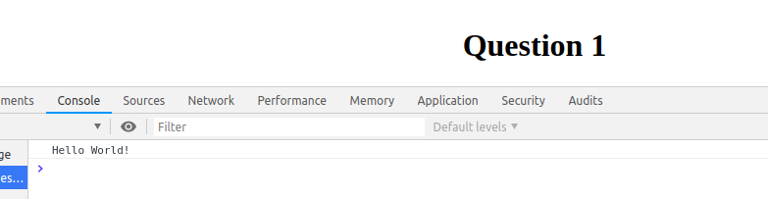

1. **Select a ID name "#test" and add class "load" when DOM is loaded**

**index.html**

<!DOCTYPE html>

<html>

<head>

<title>Learn Jquery</title>

<script src="../jquery-3.3.1.min.js"></script>

<style type="text/css">

*{

text-align: center;

margin-top: 120px;

}

</style>

</head>

<body>

<h1 id="test">Kamal</h1>

<script type="text/javascript" src="app.js"></script>

</body>

</html>

**app.js**

$(document).ready(function(){

$('#test').addClass("load");

});

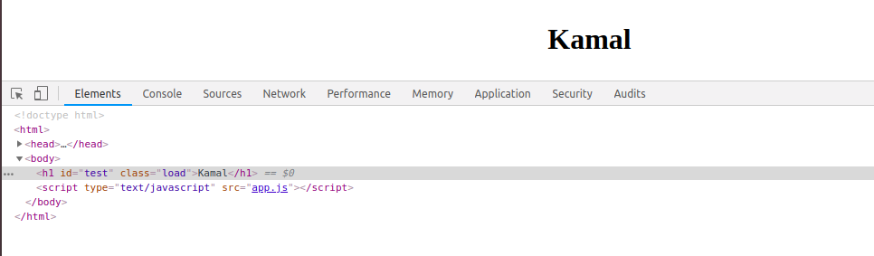

1. **Change the color of element which class name end with "-new"**

**index.html**

<!DOCTYPE html>

<html>

<head>

<title>Learn Jquery</title>

<script src="../jquery-3.3.1.min.js"></script>

<style type="text/css">

*{

text-align: center;

margin-top: 120px;

}

</style>

</head>

<body>

<h1 class="to-the-new">My name is Kamal.</h1>

<script type="text/javascript" src="app.js"></script>

</body>

</html>

**App.js**

$(document).ready(function(){

$('[class$=-new]').css('color','blue');

});

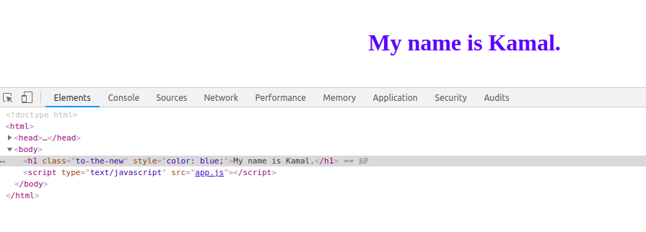

1. **Disable submit button using jquery attr method**

**Index.html**

<!DOCTYPE html>

<html>

<head>

<title>Learn Jquery</title>

<script src="../jquery-3.3.1.min.js"></script>

<style type="text/css">

h1{

text-align: center;

margin-top: 120px;

}

form{

text-align: center;

}

</style>

</head>

<body>

<h1 class="to-the-new">Kamal.</h1>

<form>

Name: <input type="text" name="name">

<button type="submit">Submit</button>

</form>

<script type="text/javascript" src="app.js"></script>

</body>

</html>

**App.js**

$(document).ready(function(){

$(':button').attr('disabled','disabled');

});

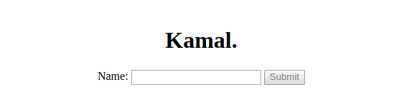

1. **Change the font size of ".target" which has parent element with id name "#main"**

**Index.html**

<!DOCTYPE html>

<html>

<head>

<title>Learn Jquery</title>

<script src="../jquery-3.3.1.min.js"></script>

<style type="text/css">

*{

text-align: center;

margin-top: 120px;

}

</style>

</head>

<body>

<div id="main">

<p class="target">This is a paragraph!</p>

<p class="target1">This is another paragraph!</p>

</div>

<script type="text/javascript" src="app.js"></script>

</body>

</html>

**App.js**

$(document).ready(function(){

$('#main > .target').css('font-size','50px');

});

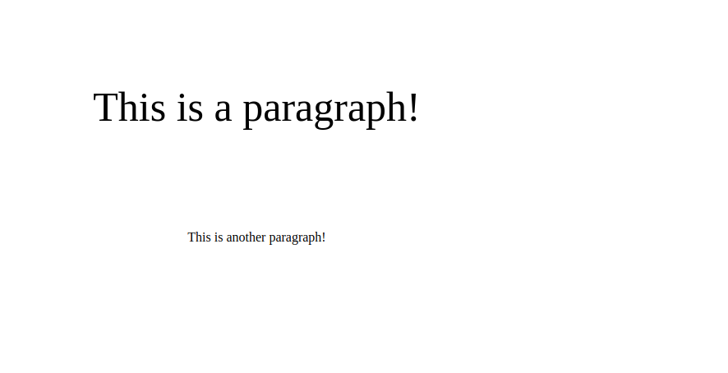

1. **After page load change the HTML of div element with "p" element**

**Index.html**

<!DOCTYPE html>

<html>

<head>

<title>Learn Jquery</title>

<script src="https://ajax.googleapis.com/ajax/libs/jquery/3.3.1/jquery.min.js"></script>

</head>

<body>

<div>

<P class="target" style="font-size: 25px;">My name is kamal!</P>

</div>

<script type="text/javascript" src="app.js"></script>

</body>

</html>

**App.js**

$(document).ready(function(){

$(function(){

if(document.readyState==='complete')

{

var p=$("<p/>",{class:'class1',id:'id1',text:'To the new!'});

$("div").html(p);

}

});

});

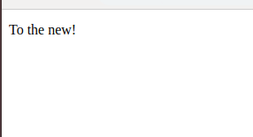

1. **Bind a click function to an "click" element and append next "click" next to it.**

**Index.html**

<!DOCTYPE html>

<html>

<head>

<title>Learn Jquery</title>

<script src="https://ajax.googleapis.com/ajax/libs/jquery/3.3.1/jquery.min.js"></script>

</head>

<body>

<div class="click" style="text-align: center; margin-top: 250px; font-size: 20px; color: red;">Click</div>

<script type="text/javascript" src="app.js"></script>

</body>

</html>

**App.js**

$(document).ready(function(){

$('.click').click(function(){

$('.click').append(' Click');

});

});



1. **Click event not working on element which added dynamicly or via script, make it work using .on method**

**Index.html**

<!DOCTYPE html>

<html>

<head>

<title>Learn Jquery</title>

<script src="https://ajax.googleapis.com/ajax/libs/jquery/3.3.1/jquery.min.js"></script>

</head>

<body>

<div class="class1"></div>

<script type="text/javascript" src="app.js"></script>

</body>

</html>

**App.js**

$(document).ready(function(){

$(function(){

var append1=$("<p/>",{class:'class1',id:'id1',text:'hello world'});

$("div").append(append1);

});

$(".class1").on("click", function(){

alert("alert key working!");

});

});

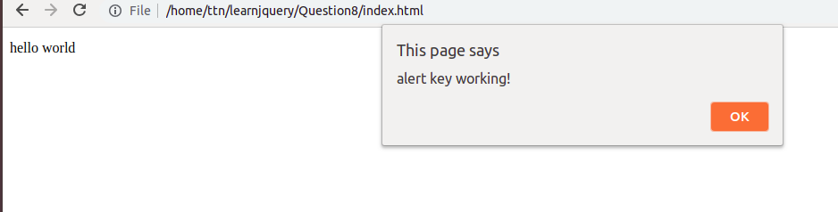

1. **Get dropdown selected value on onchanage event and append in div container**

**Index.html**

<!DOCTYPE html>

<html>

<head>

<title>Learn Jquery</title>

<script src="https://ajax.googleapis.com/ajax/libs/jquery/3.3.1/jquery.min.js"></script>

</head>

<body>

<select>

<option>kamal</option>

<option>joyesh</option>

<option>shivangi</option>

<option>sukirti</option>

</select>

<div style="color:red; text-align: center;font-size: 29px;">on change event: </div>

<script type="text/javascript" src="app.js"></script>

</body>

</html>

**App.js**

$(document).ready(function(){

$(function(){

$('select').on('change',function(){

$('div').append(this.value);

});

});

});

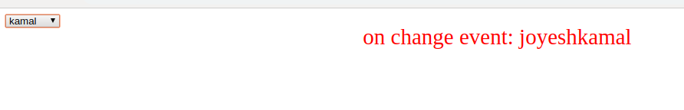

1. **Create a dropdown menu using hover method in jquery**

**Index.html**

<!DOCTYPE html>

<html>

<head>

<title>Learn Jquery</title>

<script src="https://ajax.googleapis.com/ajax/libs/jquery/3.3.1/jquery.min.js"></script>

</head>

<body>

<div id="p1">

<p>kamal pandey</p>

<ul style="display: none;">

<li>name</li>

<li>age</li>

<li>contact</li>

</ul>

</div>

<script type="text/javascript" src="app.js"></script>

</body>

</html>

**App.js**

$(document).ready(function(){

$('#p1').hover(function() {

$('#p1').children('ul').slideDown('medium');

},

function(){

$('#p1').children('ul').slideUp('medium');

});

});

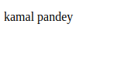

1. **On clicking on "**[**google**](https://www.google.com/)**" tag. It is taking us to google home page. Stop it from happening.**

**Index.html**

<!DOCTYPE html>

<html>

<head>

<title>Learn Jquery</title>

<script src="https://ajax.googleapis.com/ajax/libs/jquery/3.3.1/jquery.min.js"></script>

</head>

<body>

<a href="https://www.google.com/" id="ref">google</a>

<script type="text/javascript" src="app.js"></script>

</body>

</html>

**App.js**

$(document).ready(function(){

$("a").click(function(){

event.preventDefault();

alert("you cannot access this site")

});

});

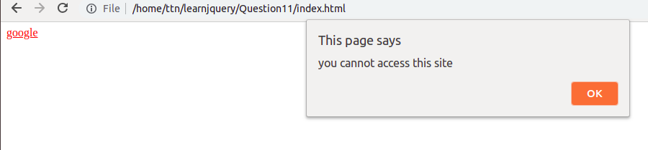

1. **We have bind a click function to parent div but we want stop it from performing when user clicks on its child li**

**Index.html**

$(document).ready(function() {

$("#d1").click(function(e){

if(e.target.id != this.id) return;

$("#d1").append("<p>click event fired</p>");

});

$('ul').hide();

$('p').click(function(){

$('ul').show();

});

});

**App.js**

$(document).ready(function() {

$("#d1").click(function(e){

if(e.target.id != this.id) return;

$("#d1").append("<p>click event fired</p>");

});

$('ul').hide();

$('p').click(function(){

$('ul').show();

});

});

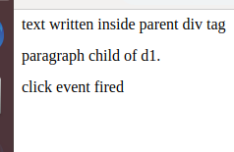

1. **Get the max height of elements using jquery each method**

**Index.html**

<!DOCTYPE html>

<html>

<head>

<title>Learn Jquery</title>

<script src="https://ajax.googleapis.com/ajax/libs/jquery/3.3.1/jquery.min.js"></script>

</head>

<body>

<p>Lorem Ipsum is simply dummy text of the printing and typesetting industry. Lorem Ipsum has been the industry's standard dummy text ever since the 1500s, when an unknown printer took a galley of type and scrambled it to make a type specimen book. It has survived not only five centuries, but also the leap into electronic typesetting, remaining essentially unchanged. It was popularised in the 1960s with the release of Letraset sheets containing Lorem Ipsum passages, and more recently with desktop publishing software like Aldus PageMaker including versions of Lorem Ipsum</p>

<div>It is a long established fact that a reader will be distracted by the readable content of a page when looking at its layout. The point of using Lorem Ipsum is that it has a more-or-less normal distribution of letters, as opposed to using 'Content here, content here', making it look like readable English. Many desktop publishing packages and web page editors now use Lorem Ipsum as their default model text, and a search for 'lorem ipsum' will uncover many web sites still in their infancy. Various versions have evolved over the years, sometimes by accident, sometimes on purpose (injected humour and the like).</div>

<script type="text/javascript" src="app.js"></script>

</body>

</html>

**App.js**

$(document).ready(function(){

$(function(){

var max = -1;

$("div").each(function() {

var h = $(this).height();

max = h > max ? h : max; // maximum height

});

alert(max);

});

});

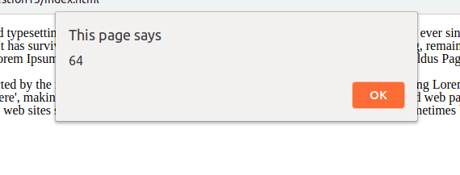

1. **Chagne color of every cell which has number larger than 10.**

**Index.html**

<!DOCTYPE html>

<html>

<head>

<title>Learn Jquery</title>

<script src="https://ajax.googleapis.com/ajax/libs/jquery/3.3.1/jquery.min.js"></script>

<style type="text/css">

table, th, td {

text-align: center;

width:150px ;height:50px;

border: 1px solid black;

}

</style>

</head>

<body>

<center>

<table>

<tr>

<th>numbers</th>

<th>numbers</th>

<th>numbers</th>

</tr>

<tr>

<td>382</td>

<td>3223</td>

<td>12</td>

</tr>

<tr>

<td>1</td>

<td>2</td>

<td>40</td>

</tr>

</table>

</center>

<script type="text/javascript" src="app.js"></script>

</body>

</html>

**App.js**

$(document).ready(function(){

$("td").each(function(){

if($(this).text() > 10){

$(this).css({'color':'red'});

}

});

});

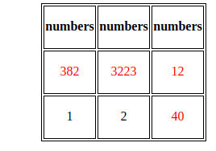

1. **Retrive the data from server using ajax get call**

**Index.html**

<!DOCTYPE html>

<html>

<head>

<title>Learn Jquery</title>

<script src="https://ajax.googleapis.com/ajax/libs/jquery/3.3.1/jquery.min.js"></script>

</head>

<body>

<div> </div>

<script type="text/javascript" src="app.js"></script>

</body>

</html>

**App.js**

$(document).ready(function(){

$.ajax({url: 'https://api.myjson.com/bins/cr6wu', method: 'Get', success: function(result){

console.log(result);

$('div').text(JSON.stringify(result));

}});

});



1. **Add cross button on row and bind click function which make a delete request to server, after success event remove the row from dom.**

**Doult in this question!**

1. **Create a image array and in div create a slide show to animate images of delay of 500ms.**

**Index.html**

<!DOCTYPE html>

<html>

<head>

<title>Learn Jquery</title>

<script src="https://ajax.googleapis.com/ajax/libs/jquery/3.3.1/jquery.min.js"></script>

<style>

#slider {

opacity: 1;

width: 500px;

height: 200px;

background-color: blue;

}

</style>

</head>

<body>

<div id="slider">Hover here to start slideshow<img id="slide-img"></div>

<script type="text/javascript" src="app.js"></script>

</body>

</html>

**App.js**

$(document).ready(function () {

var imageArray = ["https://images.pexels.com/photos/459225/pexels-photo-459225.jpeg?auto=compress&cs=tinysrgb&dpr=1&w=500",

"https://images.pexels.com/photos/248797/pexels-photo-248797.jpeg?auto=compress&cs=tinysrgb&dpr=1&w=500",

"https://images.pexels.com/photos/34950/pexels-photo.jpg?auto=compress&cs=tinysrgb&dpr=1&w=500",

"https://images.pexels.com/photos/33109/fall-autumn-red-season.jpg?auto=compress&cs=tinysrgb&dpr=1&w=500"]

$("#slider"). click(function () {

var image = $("#slide-img");

image.animate({ opacity: 0 }, 500, function () {

var random = imageArray[Math.floor(Math.random() * imageArray.length)];

image.attr("src", random);

image.css('opacity', 1);

$("#slider").html(image);

})

})

});

